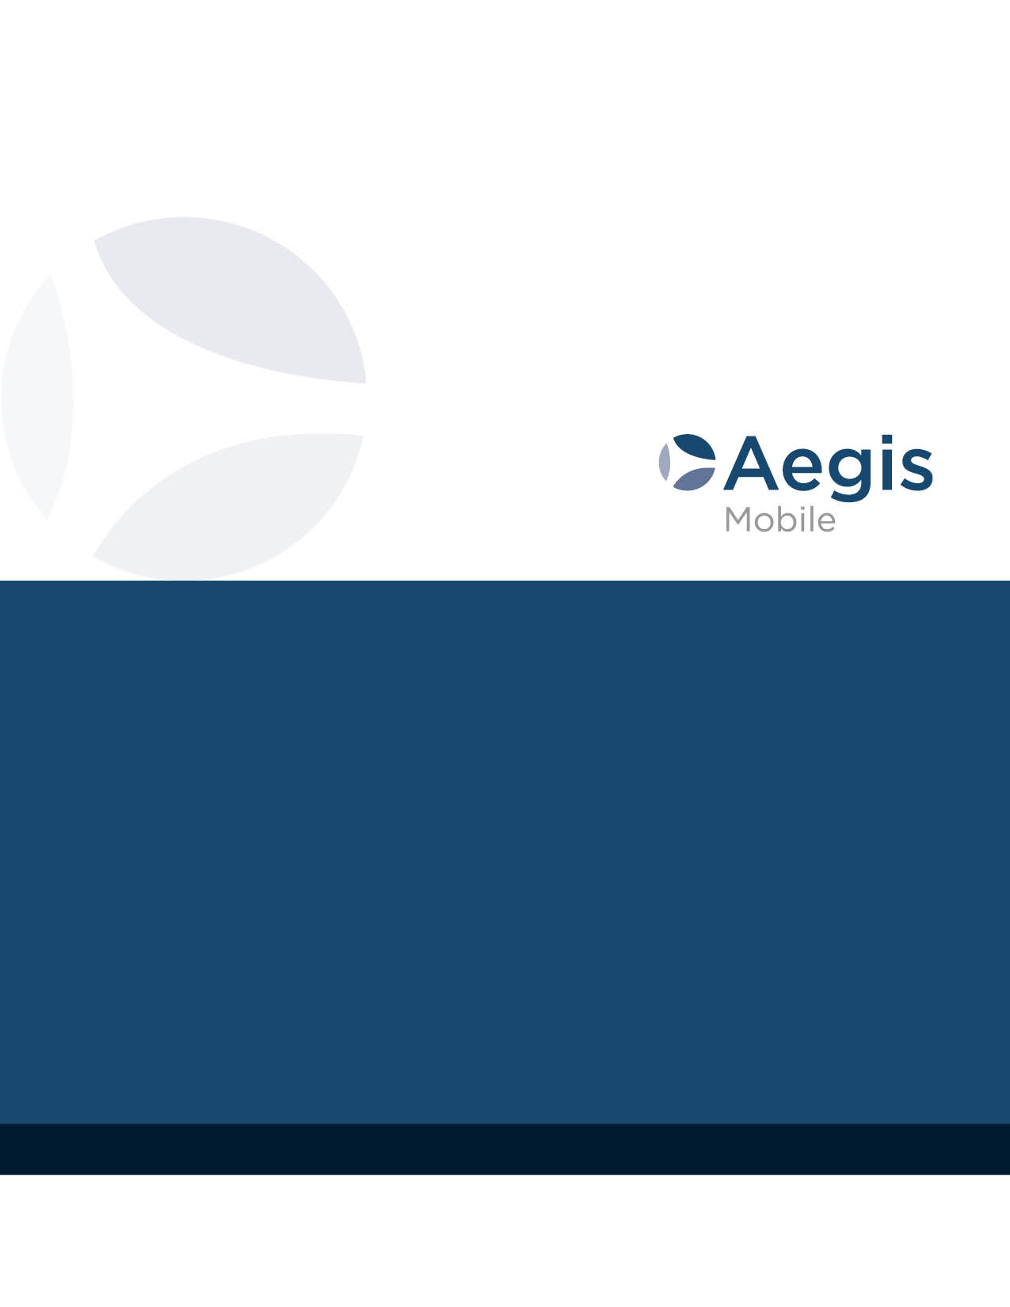

Aegis Mobile, LLC

Offices in multiple locations

Software Developer

# Aegis Overview

****Aegis is a global leader in brand protection, fraud detection, 3rd party integrity assurance, channel risk management, and multi-source data intelligence. Aegis utilizes the most sophisticated Internet and mobile web surveillance and capture tools available today to hunt, capture and retain dynamic and static information to deliver:

* Business Analytics for Brand Protection and Compliance
* 3rd Party Partner Risk Assessment and Monitoring
* Market Intelligence, SEO Performance, and
* Operational Insight and Transformation

Aegis provides multi-level investigative solutions to its clients through proprietary software tools that integrate and transform data into actionable information with intuitive user interfaces, APIs, and data analytics pipelines.

# Aegis Solutions

The Company operates two highly focused business units:

* Brand Protection and Third-party Risk Management
* Multi-source Business Intelligence and Analytics

Our systems are designed to be customized to meet the individual customer’s processes and objectives. In its brand and partner protection products and services, Aegis “connects the dots” using proprietary software to create business insight as well as partner and program visibility across business channels to improve performance, risk mitigation, and management efficiency. For its business intelligence and analytics services, Aegis integrates customers’ data with open-source information from across the Internet to deliver customized, actionable, world class business intelligence.

# Position: Software Developer

## Need Statement

Aegis seeks a skilled and energetic software developer to support the operation and evolution of custom software and database applications underlying the key counter-fraud and market intelligence services that are core to Aegis Mobile’s growing business.

## Job Summary

The Software Developer performs full life-cycle development as well as maintenance of existing applications. He or she is a strong individual contributor with a predisposition to collaborate in an agile team environment. This team member is responsible for the support, development and implementation of data driven web applications. He or she collaborates with Product Managers and Operations to define new product features for web applications and provides ongoing day-to-day support of existing web and database applications.

## Responsibilities

* Analyze current applications including performance, diagnosis and troubleshooting of issues, and design solutions for detected problems
* Conduct system analysis and development, with support from professional staff, to keep our systems current with changing technologies
* Respond promptly and professionally to bug reports
* Provide assistance to testers and support personnel as needed to determine and correct system problems
* Demonstrate strong and effective inter-personal and communication skills, and the ability to interact professionally with a diverse group of clients and staff
* Develop new applications and follow through with documentation, testing, integration and debugging to ensure production of a quality product with required functionality
* Design and develop systems making specific design decisions about system performance
* Utilize and suggest improvements to tools and equipment needed to perform the essential functions of development and database management
* Test new applications at multiple levels to ensure that logic and syntax are correct, and that method/module results are accurate
* Continuously learn and apply advanced software and database design principles to develop novel high-performance solutions to evolving industry problems

## Knowledge and Skill Requirements

* Visual Studio
* C#
* ASP.NET Web Form, ASP.NET Core, MVC, Web API
* SQL Server, Azure SQL DB
* HTML/CSS
* JavaScript
* Web Services
* Source Control Systems (Git)
* Excellent written and verbal communication skills
* Excellent technology and collaboration skills
* Strong troubleshooting and problem-solving skills

## Additional Desirable Knowledge and Skills

* LINQ and Entity Framework
* Angular/React or similar framework
* MVC5
* Java, Python
* TypeScript
* DevOps Automation
* Microsoft Azure/Amazon AWS/Google Cloud
* Social Media Aggregation/Mining

## Qualifications

* One to Two years of direct or relevant professional experience (may include post-graduate academic experience)
* Four-year Baccalaureate degree in a relevant discipline (Computer Science or equivalent)
* Self-motivated, creative, and efficient in proposing solutions to complex, time critical problems
* Works effectively in a highly collaborative team environment

## Why You’ll Want to Work with Aegis:

Aegis is an innovative, diverse, and dynamic company with tightly woven teams constantly exploring new ways to produce advantages for our clients. With offices in Maryland, Virginia, Alabama, and Sydney Australia, we provide opportunities to work in a variety of settings and use the collaborative brainpower around you to ask and answer interesting questions. We have a broad range of backgrounds and interests: experts in fields such as finance, real estate, politics, and naval engineering, come together to make an intriguing and educational work environment. We offer excellent benefits and competitive salaries.